 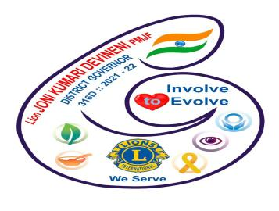

**We Serve**

**THE INTERNATIONAL ASSOCIATION OF LIONS CLUBS**

**DISTRICT-316.D 2021-2022**

**LIONS CLUB OF VIJAYAWADA**

**C.V.R**

**CLUB NO:-142345 REGION:-VI-ZONE.1**

**INVITATION**

**INTERNATIONAL DOCTOR’S DAY CELEBRATIONS**

**Felicitation programme**

**DR.J. Srimannarayana M.D , D.M**

**Chief Cardiologist**

**Heart & Brain Institute**

**Andhra Hospital**

**Vijayawada**

**Date:- 01-07-2021**

**Thursday**

**11:30 A.M**

**Place:- Andhra Hospital , Nakkal road**

**Chief guests:- Ln. Y. Srinivasa Rao ( Regional Chairman )**

**Ln. A . Sarabandi Rao ( Zonal Chairman )**

**Guest:- Ln. Sk. Abdul Rasheed (Immediate past president )**

**Vijayawada C.V.R lions club.**

**Ln. M.S Imam Basha**

**President**

**Ln. P. Madhu Babu Ln. G . Janaki Ram Prasad**

**Secretary Treasurer**

***Slogan:-We Serve*   *Theme*:-*Involve to Evolve***